# Capstone 2: Convolutional Neural Network - Crowd Counting

Contents

Capstone 2: Convolutional Neural Network - Crowd Counting 1

Preface 3

Problem Statement 3

Use case for crowd counting 3

Explanatory Data Analysis 4

Data Collection 4

Data Validation 4

Benchmarking 5

Data Preprocessing – RGB to HSV conversion 5

Training Part 1 – Initial Training 7

Preface - Training 7

Baseline Training 7

Best Performance 7

Worst Performance 7

A note on models 7 & 8 – AlexNet variations 7

Training Part 2 – Improving AlexNet Transfer Learning 8

AlexNet Architecture Overview 8

Current Issues with AlexNet Transfer Learning 8

AlexNet Training 9

Next Steps 9

Training Part 3 – Augmenting the dataset sample 10

Training Part 4 – Feature Extraction from the Dataset 11

Appendix 12

Trained Models 12

## Preface

Convolutional networks have existed for over 30 years. First proposed in 1979 by Kunihiko Fukushima, a neocognitron system (hierarchical, multilayered artificial neural network) would become the basis for modern day convolutional neural networks.

Today, convolutional neural networks play an important role in many image classification problems from cancer detection to self driving cars.

## Problem Statement

Given an image from a mall webcam, can a convolutional neural network count the number of people in the frame?

For example, can a CNN model count the 29 people in the frame below:

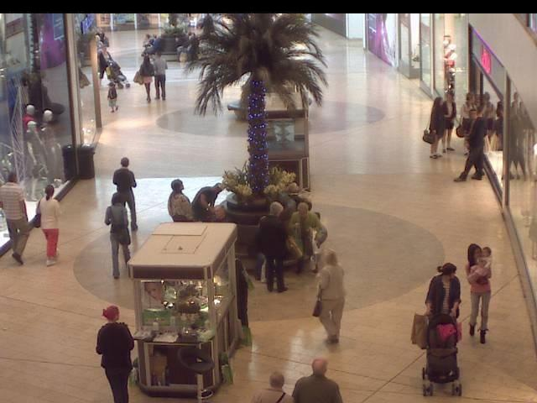

## Use case for crowd counting

There are many use cases for crowd counting in the context of a mall images. To name a few:

* Counting crowds could act as a proxy for overall retail economic conditions.
* Crowd counting for specific retailers could provide the basis for long/short stock purchases[1]
* A mall could offer high traffic areas to specific retailers and charge more (ex. Apple)
* The feature extraction process for counting a crowd could be useful for other applications through transfer learning (ex. Crowd counting at a political rally, estimations of animal populations using a webcam in the forest etc.)
* Further advances in a crowd counting context could provide additional details on people in the image (demographics, time of day, etc.)

# Explanatory Data Analysis

## Data Collection

The data was sourced from associate professor Chen Change Loy’s personal website[2].

The process to extract the images involved processing a series of .mat files with matlab.

The output of the matlab processing was:

* 2,000 640x480 RGB frames from a mall webcam.
* an associated target variable which represents the number of people in each frame.

## Data Validation

Prior to training, several frames were evaluated to confirm the target value was valid. Below are two example frames and their associated target values:

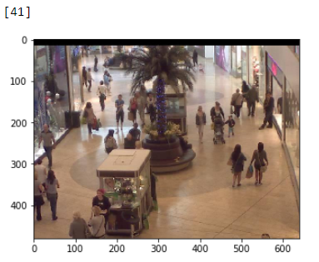

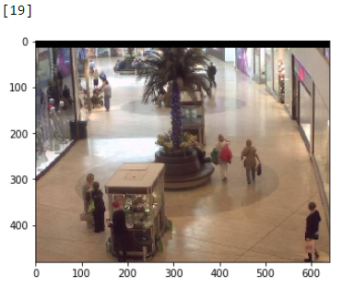

## Benchmarking

To get a general idea of model performance, a benchmark was created using the average target variable (where target variable is equal to the number of people in a given frame).

The mean value for the target variable is **31.16** for the 2,000 frames.

Plotting the target variable results in the following distribution:

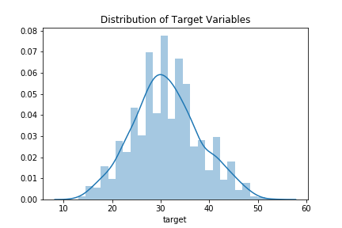

To create a benchmark MSE, the MSE was calculated assuming we choose the mean for every frame in the dataset.

Calculating the benchmark MSE in this manner results in a value of **48.21**. This value will serve as a starting comparison for our trained model.

## Data Preprocessing – RGB to HSV conversion

Prior to training the model, the RGB images were transformed to an HSV (“hue, saturation, value”) format. From the HSV format, the “value” was extracted to form 2,000 samples with the tensor shape of 640x480x1.

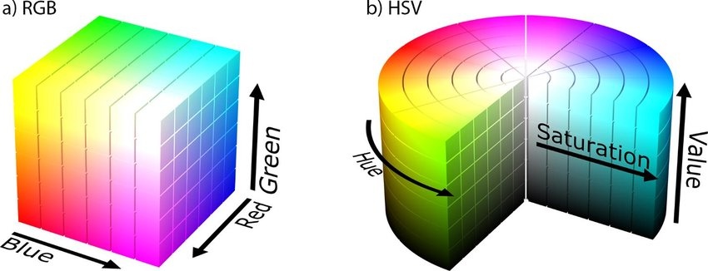[3]

The change in format to HSV was done due to the model likely not requiring a 3-dimensional tensor to filter out shapes form the image. If for example, we were interested in counting people who wore red shirts, then the use of RGB channels would be necessary.

Converting to HSV simplifies the data by encoding information from 3 dimensions to 1 dimension. Through the conversion, there is a non-zero loss in the overall information that each frame provides. However, the benefits of the conversion are a simplified tensor which reduces overall model complexity and improves train time.

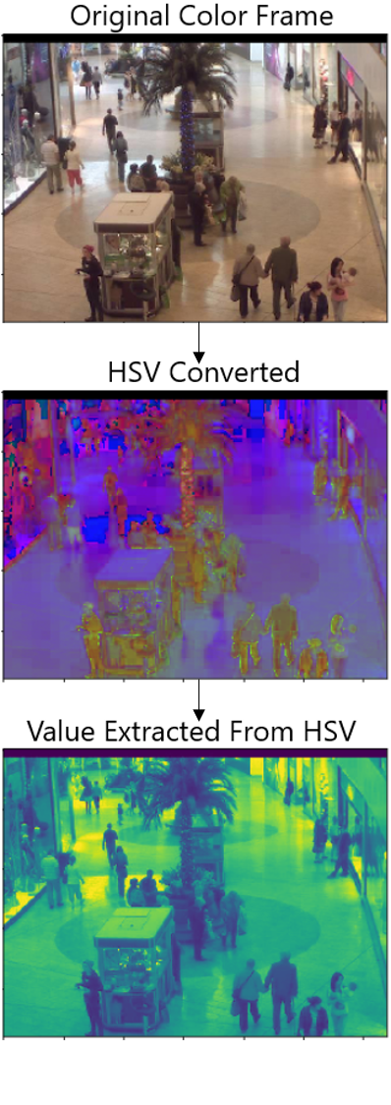

# Training Part 1 – Initial Training

## Preface - Training

* Training was completed on a [Nvidia GeForce GTX 1660 TI graphics card.](https://www.notebookcheck.net/NVIDIA-GeForce-GTX-1660-Ti-Laptop-Graphics-Card.386426.0.html)
* All pixel tensor inputs were normalized to values between 0 and 1. This was done to avoid gradient exploding and to improve overall train performance.
* Training was done through a Keras generator to reduce the overall memory overhead of running the models.

## Baseline Training

To complete the training, a Jupyter Notebook was created that referenced different models for testing. Abstracting the models away allowed for further small adjustments to models that performed well.

During the initial training, the following models were tested:

|  |  |  |  |  |  |  |  |
| --- | --- | --- | --- | --- | --- | --- | --- |
| **Model** | **Model Name** | **# of layers** | **DO** | **BN** | **Activation** | **Parameters** | **Val MSE** |
| 1 | Basic CNN | 1 |  |  | Relu | 130,515,833 | 15.77 |
| 2 | Basic CNN v2 | 2 |  |  | Relu | 62,891,665 | 11.35 |
| 3 | Basic CNN v2 DO | 2 | X |  | Relu | 62,891,665 | 44.41 |
| 4 | Basic CNN v2 BN | 2 |  | X | Relu | 62,893,073 | 11.01 |
| 5 | Basic CNN v2 DO LR | 2 | X |  | LeakyRelu | 62,891,665 | 10.56 |
| 6 | Basic CNN v2 BN LR | 2 |  | X | LeakyRelu | 62,893,073 | 10.66 |
| 7 | AlexNet Transfer Learning[4] | 7 | X | X | Relu | 13,011,313 | 244.97 |
| 8 | AlexNet Transfer Learning LR | 7 | X | X | LeakyRelu | 13,014,257 | 19.53 |

DO = Dropout | BN = Batch Normalization

## Best Performance

The best performing model was surprisingly model 5 (Basic CNN v2 DO LR) which used dropout and LeakyRelu activations.

We also see model improvements between model 2 and model 5&6 by adding a LeakyRelu activation.

## Worst Performance

Interestingly, model 7 (adjusted AlexNet) model had the worst performance. Adding LeakyRelu as an activation improved the performance of model 7 ten fold. This would suggest an issue with a vanishing gradient.

## A note on models 7 & 8 – AlexNet variations

The modification to the AlexNet architecture was removing a dense layer with 4096 perceptrons after the convolutional filters were flattened. This was done due to the computer not having enough memory to apply the tensor to the model. Removing the dense layer drastically reduces the number of trained parameters significantly and creates a simplified AlexNet model. In future training, the dense layer will be added back in an attempt to encapsulate more complexity from the features since the model did not perform well.

# Training Part 2 – Improving AlexNet Transfer Learning

## AlexNet Architecture Overview[5]

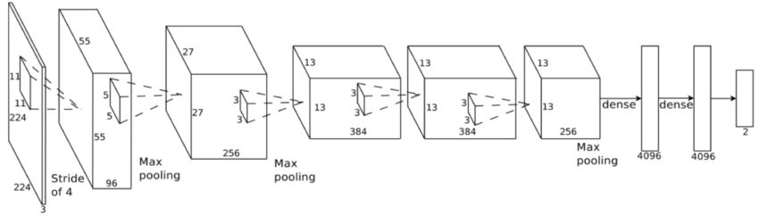

## Current Issues with AlexNet Transfer Learning

Using the AlexNet architecture above comes with a couple of problems:

1. Firstly, the issue of vanishing gradient. Based on results from the initial training, adding a LeakyRelu activation to the layers will likely circumvent this issue.
2. Secondly, with input tensor of shape 640x480, after the convolutional layers have been applied, the flattening layer causes a memory overflow error. In order to circumvent this issue, one of three things could be done.
   1. Reduce the tensor size on convolution layers through increasing the kernel/strides.
   2. Reduce the tensor size on the pooling by increasing kernel/strides.
   3. Reduce the dense layer number of perceptrons after the tensor is flattened.

To avoid the overflow error, **option c** was selected. This was done due to keep the overall filters outputs the same. However, this does reduce the models ability to pick up on non-linear relationships between output layer perceptrons.

Option c was selected because of the models simplicity in that it is merely counting objects rather than combining a number of features to classify an image (as per the objective of the original paper). Put another way, people in the upper left corner of the frame have no relation to those in the lower right. As such, there is no need for such complexity or connectiveness between perceptrons that are activated in those corners.

## AlexNet Training

After making the adjustments described above, the following AlexNet models were trained:

|  |  |  |  |  |  |  |  |
| --- | --- | --- | --- | --- | --- | --- | --- |
| **Model** | **Model Name** | **# of layers** | **DO** | **BN** | **Activation** | **Parameters** | **Val MSE** |
| 9 | AlexNet_trasfer actual | 8 | X | X | Relu | 110,887,769 | 23.08 |
| 10 | AlexNet transfer DO | 8 | X |  | Relu | 110,882,265 | 28.80 |
| 11 | AlexNet transfer BE | 8 |  | X | Relu | 110,887,769 | 15.69 |
| 12 | AlexNet transfer BE LR | 8 |  | X | LeakyRelu | 110,887,769 | 12.86 |

DO = Dropout | BN = Batch Normalization

Model 12 had the best performance overall (12.85 MSE), however, the validation MSE varied substantially between epochs. This would suggest overfitting of the model. Adjustments to the dataset or the model are required to improve model performance.

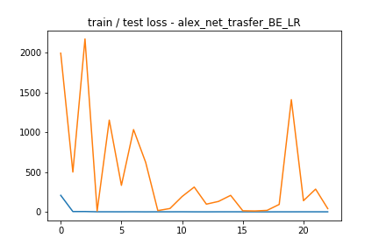

Model 11 had the best out of the AlexNet variations in terms of it’s ability to generalize to new data.

## Next Steps

The AlexNet variations are more complex models, yet, they perform worse than the basic 2-layer networks.

This could suggest a number of issues such as:

* Overfitting
* Too small of sample
* Too much complexity in the network (too many layers)

To improve the AlexNet models, the following will be tested:

1. Increase sample size through image generation
2. Reduce the overall complexity of the models
3. Preprocessing on the original dataset to improve the models ability to pick up on changes in the image.

# Training Part 3 – Augmenting the dataset sample

To improve the

# Training Part 4 – Feature Extraction from the Dataset

In order to improve accuracy of the model further, the dataset was normalized by removing the background noise each frame. This was done by subtracting the mean image of the dataset from each frame.

The motivation behind this data adjustment is to try and make the

# Appendix

## Trained Models

Model: " Basic CNN"

_______________________________________________

Layer (type) Output Shape Param #

=================================================================

lambda_1 (Lambda) (None, 480, 640, 1) 0

_________________________________________________________________

conv2d_1 (Conv2D) (None, 118, 158, 56) 6832

_________________________________________________________________

max_pooling2d_1 (MaxPooling2 (None, 59, 79, 56) 0

_________________________________________________________________

flatten_1 (Flatten) (None, 261016) 0

_________________________________________________________________

dense_1 (Dense) (None, 500) 130508500

_________________________________________________________________

dense_2 (Dense) (None, 1) 501

=================================================================

Total params: 130,515,833

Trainable params: 130,515,833

Non-trainable params: 0

_________________________________________________________________

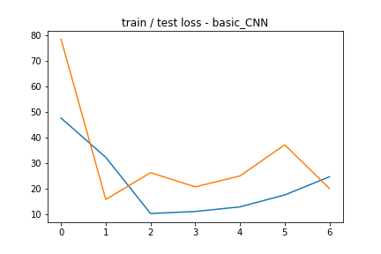

1. <https://www.theatlantic.com/magazine/archive/2019/05/stock-value-satellite-images-investing/586009/>
2. <http://personal.ie.cuhk.edu.hk/~ccloy/downloads_mall_dataset.html>
3. Images by Michael Horvath, available under Creative Commons Attribution-Share Alike 3.0 Unported license.
4. Transfer learning model – Variations made to the Alexnet architecture: <https://papers.nips.cc/paper/4824-imagenet-classification-with-deep-convolutional-neural-networks.pdf>
5. <https://www.researchgate.net/figure/AlexNet-CNN-architecture-layers_fig1_318168077>